WEBD 1000 Assignment #1 - Tutorial 1 Case Problem 2 (HTML 81)

Website Development

* **Due: Submitted before the date and time specified on the Brightspace Assignment 1 Dropbox object**

# Instructions

1. Complete Case Problem #2 from Tutorial 1 on page **HTML 81**(Section 1-25g) of the textbook.
2. You will demonstrate the completion of this project via a **video screen-capture recording** of you navigating your completed Website in the **browser** (e.g. Chrome) and viewing your **code** in the text editor (e.g. NotePad++) to show completion of the attached rubric/checklist. You will post **either your video file or a link to it** (e,g, a Microsoft Stream recording, make sure to give the instructor permissions to watch it), to the Brightspace Assignment 1 Dropbox prior to the deadline. If you are not sure of how best to capture such a video, seek advice from the instructor prior to the deadline.

NOTE: YOU DO NOT NEED TO HAVE AUDIO OR SPEAK DURING THE VIDEO. HOWEVER, IF YOU CHOOSE NOT TO, THEN YOUR VIDEO MUST VERY CLEARLY SHOW EVERYTHING IN THE RUBRIC/CHECKLIST AS THERE WILL BE NO AUDIO TO TELL WHAT IT IS THAT YOUR ARE SUPPOSED TO BE SHWOING IN A GIVEN STEP.

1. This is to be an individual assignment (i.e. not group work).
2. The rubric/checklist on the last pages **should act as your guide of what to demonstrate in the video**. The video file (or link) should be submitted to **Brightspace** before the deadline.
3. You can also refer to the screen shots on the next page for an example of what the two pages of the website not pictured in the textbook should mostly look like.
4. That’s it.

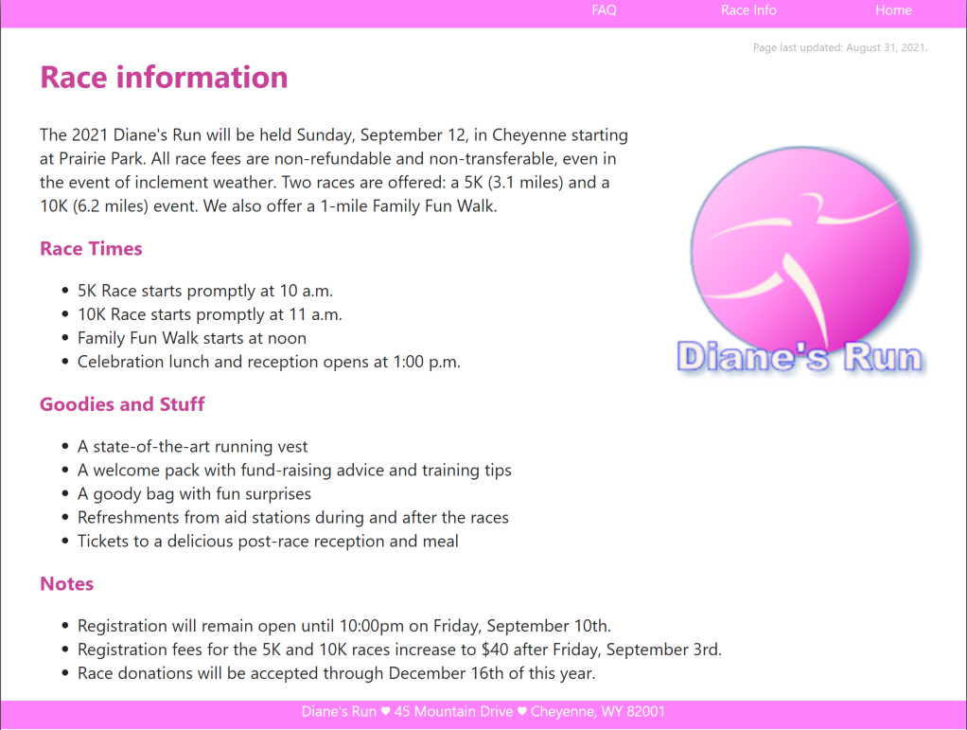

Figure - Sample dr_info.html page

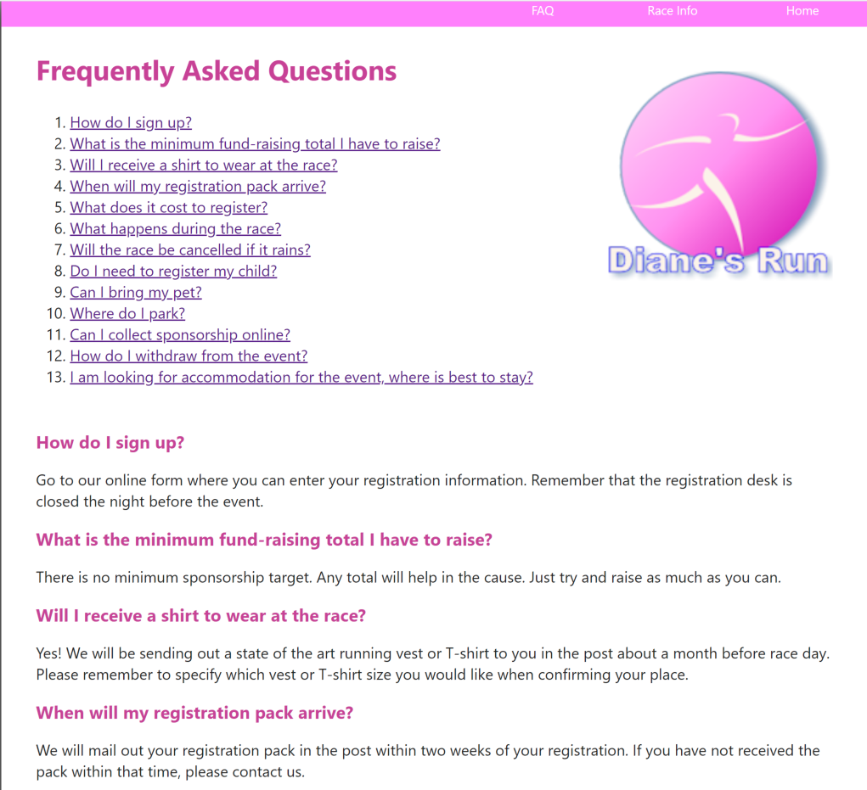

Figure - Sample dr_faq.html page

|  | **Criteria** | **How-to Demonstrate in Video** | **Unsatisfactory** | **Developing** | **Good** | **Exceptional** |
| --- | --- | --- | --- | --- | --- | --- |
| **0** | **1** | **2** | **3** |
| **Requirements** | **Page Head Sections** | -**browser**: show successful validation of all pages in W3C validator  - **code**: show comment with your name and author date  - **code**: show title,  Keywords  - **code**: show charset | - does not demonstrate | - partially demonstrates | - mostly demonstrates | - is HTML 5 compliant  - includes descriptive comment section  - includes page title, keywords  - charset is UTF-8 |
| **Navigation** | - **browser**: show all pages displaying  - **browser**: show all links working  - **code**: show structure of nav list | - does not demonstrate | - partially demonstrates | - mostly demonstrates | - all pages links are working!  - links are located in a list  - the list is located in a nav block  - the nav block is located in a header  - no errors exist |
| **Sectioning** | - **code**: show proper use of <header>  **- code**: show proper use of <footer>  **- code**: show proper use of <section> and/or <article> | - does not demonstrate | - partially demonstrates | - mostly demonstrates | - all pages and content are in well chosen and appropriate sectioning elements  - no errors exist |
| **Grouping** | - **code**: show proper use of <p>  - **code**: show proper use of <blockquote>  - **code**: show proper use of lists | - does not demonstrate | - partially demonstrates | - mostly demonstrates | - all content has been grouped correctly with appropriate grouping tags, like paragraphs, block quotes and lists  - no grouping tags were used unnecessarily  - no errors exist |
| **Text-Level** | **- code**: show proper use of <strong>, <em>, <b>, <i>, and/or <u>  - **browser**: show text that had been bolded, emphasized | - does not demonstrate | - partially demonstrates | - mostly demonstrates | - several text-level tags were added appropriately throughout the site  - no incorrect or inappropriate tags were used  - no errors exist |
| **Inline Image** | - **code**: show use of <img> tag  - **browser**: show image added to webpage | - does not demonstrate | - partially demonstrates | - mostly demonstrates | - uses an image tag correctly and gives thought to location and visual appeal |
|  | **Special Character** | - **code**: show use of special character  - **browser**: show special character added to webpage | - does not demonstrate | - partially demonstrates | - mostly demonstrates | - uses a special character correctly and gives thought to location and visual appeal |
|  | **Additional Hyperlinks** | - **code**: show use of email and phone number links  - **browser**: show external link added to webpage and opening in a new tab | - does not demonstrate | - partially demonstrates | - mostly demonstrates | - all emails, phone numbers and external websites have appropriate hyperlinks  - no errors exist |
|  | **Formatting** | - **code**: show proper indentation and code layout throughout all pages | - does not demonstrate | - partially demonstrates | - mostly demonstrates | - source code formatting never deviated from the  programmer’s layout |

# WEBD1000: Assignment One - Video Submission Checklist

|  |  |
| --- | --- |
| In the Browser  (e.g. Chrome) | Show the following:   * all pages displaying * all links working * text that had been bolded, emphasized * image added to webpage * special character added to webpage * external link added to webpage and opening in a new tab * successful validation of all pages in W3C validator |
| In Code  (e.g. NotePad++) | Show the following:   * comment with your name and author date * title, Keywords * charset * structure of nav list * proper use of <header> * proper use of <footer> * proper use of <section> and/or <article> * proper use of <p> * proper use of <blockquote> * proper use of lists * proper use of <strong>, <em>, <b>, <i>, and/or <u> * use of <img> tag * use of special character * use of email and phone number links * proper indentation and code layout throughout all pages |